create a hummingbird snag by sticking a dead branch into the ground so that it stands vertically. Place it about 50 feet from your feeder, but still within view. You may find that a territorial male uses the perch as a watch tower from which to defend a lone feeder. If this happens, see #1 below.

**3. Add a mister to your yard.** A mister is a small-hosed attachment for your regular garden hose. With the hose turned on to just a trickle, the mister, with its pinhole openings, shoots a fine spray, or mist, into the air. Hummingbirds, like all birds, will regularly bathe if a ready supply of water is at hand. But a mister in action is too much to resist! Hummingbirds love to fly through the fine spray until they are thoroughly soaked, at which point they zip off to a handy preening perch. Misters are available at hardware stores, lawn and garden centers, specialty bird stores, and by mail order.

**2. Don’t remove those spider webs.**Hummingbirds use spider web as a main ingredient in their nests. Strands of spider web hold the nest together and to the branch upon which it is built. But wait, there’s more! Hummingbirds also love to steal insects from spider webs. Insects are an important source of protein for hummingbirds, and they’ll get them any way they can. How convenient for hummingbirds to have spider webs do the catching for them.

**1. Got bullies? Add more feeders in a clump!** If you have one male hummingbird that is dominating your feeder to the exclusion of all others, there are two ways to afford your other hummingbirds a drink. One is to put up other feeders on opposite sides of your house, or out of sight of Mr. Bully. Of course, this may simply mean that you are setting up other fiefdoms for other male bullies. Perhaps a better solution is to add two or three more feeders in the vicinity of the first feeder. This will attract multiple hummingbirds, which will quickly cure your bully of his territoriality. He will not be physically able to fight off all the other hummingbirds, so he will give up trying.



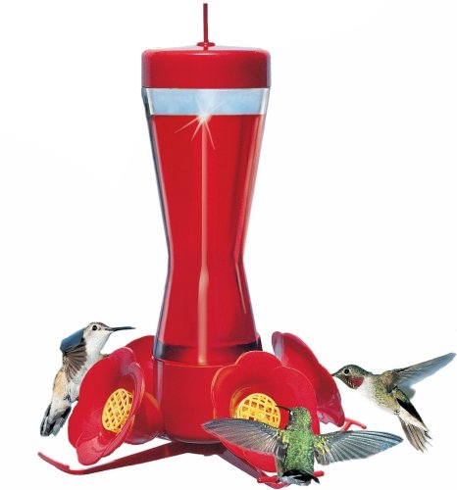**Today in the Garden**

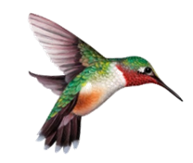**June 8, 2018**

**Attracting Hummingbirds to Your Garden**

**Top 10 Things You Can Do to Attract Hummingbirds**

by Bill Thompson, III | Editor, *Bird Watcher's Digest*

**10. Add a new native plant species to your garden.** You just can’t have too many good hummingbird plants in your garden or yard. Take an inventory of your existing offerings and consult a source of hummingbird plant information for ideas on what to add next. Good sources include plant charts in *Enjoying Hummingbirds More*, and *Creating Your Backyard Bird Garden*. Both titles are part of the *BWD* backyard booklet series, [which you can find in our online store](http://www.birdwatchersdigest.com/shop/index.php?main_page=index&cPath=66).

**9. Plan a continuous blooming schedule.**When you’re leafing through your garden catalogs or wandering the greenhouses of your favorite garden center planning your hummingbird garden, choose plant species that have different blooming periods. For example, choose a ready-to-bloom hanging basket of fuschia for early flowers, a fast-growing Salvia species for midsummer flowers, and a late-blooming trumpet creeper that will be in flower in late summer and fall. Ask a local gardening expert for advice on blooming schedules and seasons for your area, soil type, and climate. Continuous blooming means hummingbirds will always have a reason to be in your yard, especially late in the season when flower production is down but hummingbird numbers are up, with all the recently fledged youngsters.

**8. Deadhead your flowers to enhance blooming.** This old gardeners’ trick is a clever one. By removing old blossoms (this process is known as “deadheading”) shortly after they have wilted and removing seedheads from blooming plants, you trick the plants into thinking that their work is not yet done. The plants respond by continuing to produce flowers and seedheads, in the end producing far more than they would have if they had not been deadheaded. Later in the season, you can let the plants go to seed to ensure that you’ll have them back in your garden next year.

**7. Tie an orange ribbon round the old oak tree.** Use foot-long pieces of surveyor’s tape (bright red or orange plastic ribbon sold in hardware stores) to catch the eyes of passing hummingbirds. Tie these pieces to bushes, trees, deck railings—anyplace near flowers or feeders. The bright colors will lure migrant hummingbirds down from the sky for a closer look. When they get there, they’ll find your flowering gardens and hummingbird feeders, which might make them decide to stay for more than just a rest stop. Special thanks to hummingbird guru Bob Sargent for this idea.

**6. Repaint your plastic flowers; rehabilitate your old feeders.** If the red parts on your hummingbird feeders are getting a bit dull, you can repaint them using bright magenta nail polish. Make sure the nail polish is totally dry before you fill and place the feeder. When dry, the polish’s bright color is a visual signal to hungry hummers.

**5. Replace old feeders.** Don’t want to waste good nail polish and elbow grease on rehabilitating your tired, old hummingbird feeders? Don’t be a cheapskate. Go buy some new feeders. This time, get durable, heavy plastic feeders. Make sure they are designed for easy filling and that they come apart for easy cleaning. If you still insist on getting El Cheapo feeders, start saving now to buy a new batch of feeders next spring.

**4. Make snag perches for hummingbirds.**Bluebirds, kestrels, and flycatchers all like to use snags for perching. Why do they perch? To rest, to preen, but most of all, to hunt. Hummingbirds are no different. After beating your wings at a rate of 80 beats per second, you’d feel like taking a break, too. All hummingbirds, but especially males, like to perch on the end of an exposed branch. From this vantage point they can see danger or rivals approaching. And they can sally forth into the air to grab a tasty insect, should one happen to fly past. You can